How Does the Phase of Matter Affect MR Signal?

Exploring the Challenges of Solid-State NMR

Table of Contents

*Expected Learning Outcomes* 2

Background Information 2

Classwide Discussion 3

Observation Experiments: Magnetic Moment Motion Impact on Local Magnetic Environment 4

Experiment 1 5

Guided Inquiry Questions 5

Experiment 2 5

Guided Inquiry Questions 5

Testing Experiment: Molecular Motion Effect On 6

Guided Inquiry Questions 6

How Does Molecular Motion Impact Relaxation Time Constants? 7

Guided Inquiry Questions 8

Reflection Questions 8

Supplemental Readings 10

Cited Sources 10

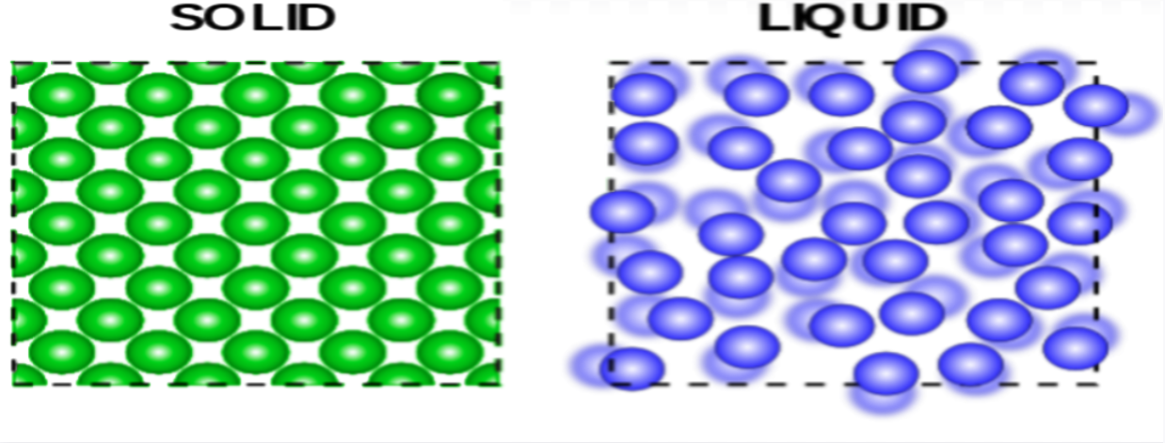

Image Source: ertunc, Public Domain, via Wikiversity (1)

## *Expected Learning Outcomes*

*At the end of this module, students should be able to…*

1. *Explain the ways that molecular motion affect the resulting NMR spectra (*[*Scientific Ability A1*](https://sites.google.com/site/scientificabilities/rubrics)*)*
2. *Predict and test how the NMR signal and frequency spectrum will differ from liquid and soft-solid samples (*[*Scientific Abilities C4 and C8*](https://sites.google.com/site/scientificabilities/rubrics)*)*
3. *Identify the challenges of solid-state NMR compared with liquid-state NMR (*[*Scientific Ability A2*](https://sites.google.com/site/scientificabilities/rubrics)*)*

**“Rocks are the key to Earth history, because solids remember but liquids and gases forget.”**

— Walter Alvarez, Geologist

# Background Information

***Example Real-World Application*** Solid-state NMR spectroscopy is a technique for characterizing chemical structure in solid materials like powders, single crystals, and tissues. Due to the limited molecular motion in the solid-state, clever strategies must be utilized to resolve the broad solid-state spectral peaks, including line-narrowing pulse sequences and [magic angle spinning](https://en.wikipedia.org/wiki/Magic_angle_spinning).

University of Cambridge, [CC BY-SA 4.0](https://creativecommons.org/licenses/by-sa/4.0), via Wikimedia Commons (2)

***Featured Chemist*** Professor Dame Clare Grey is a chemist that uses solid-state NMR and other techniques to investigate local structure and physical properties of disordered materials such as those used in rechargeable batteries and supercapacitors. Read more about her work at <https://www.ch.cam.ac.uk/person/cpg27>.

Magnetic resonance techniques can technically work with any phase of matter, as long as the sample includes sub-atomic particles with non-zero quantum spin - which is certainly the vast majority of samples! However, liquid-state NMR spectroscopy is by far the most common, and in this module we will explore why that is the case. We will see how the microscopic differences in different states of matter can impact our MR signal and ultimately determine the challenges this poses for doing NMR and MRI on non-liquid samples.

To begin our exploration, let’s first discuss what we understand about what differentiates the three states of matter illustrated in the figure below.

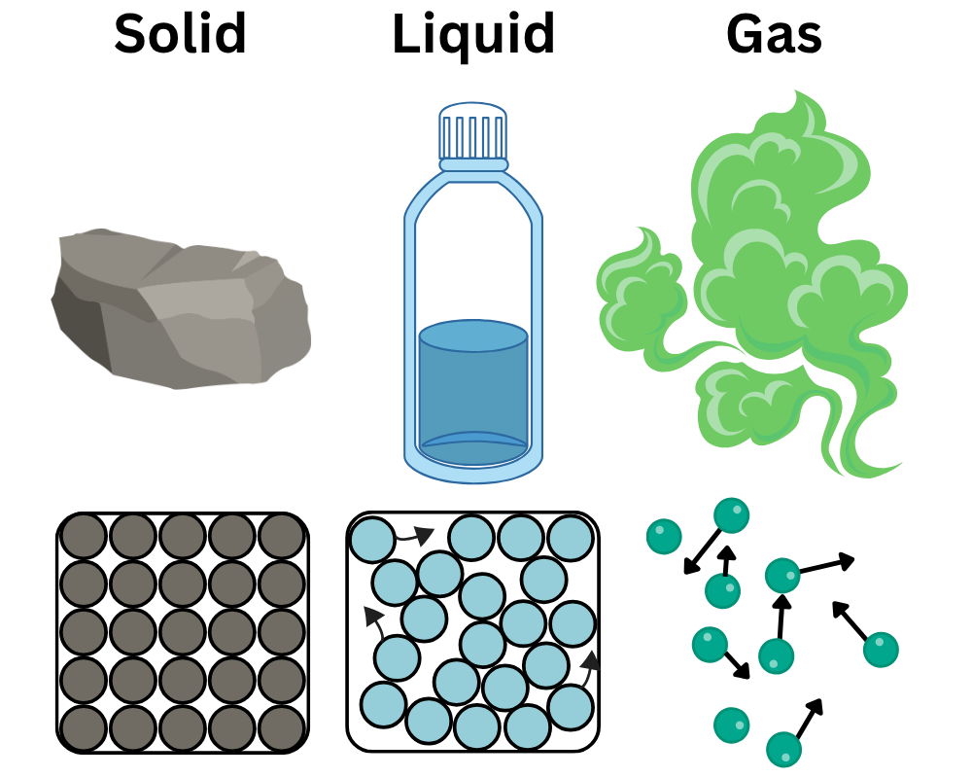

## Classwide Discussion

* What are some key differences of the three states of matter depicted in the figure shown above?
* Are there any important key differences in the three states of matter that you know about that are *not* depicted above?
* How might you revise the figure above to include these other important key differences in the three states of matter?

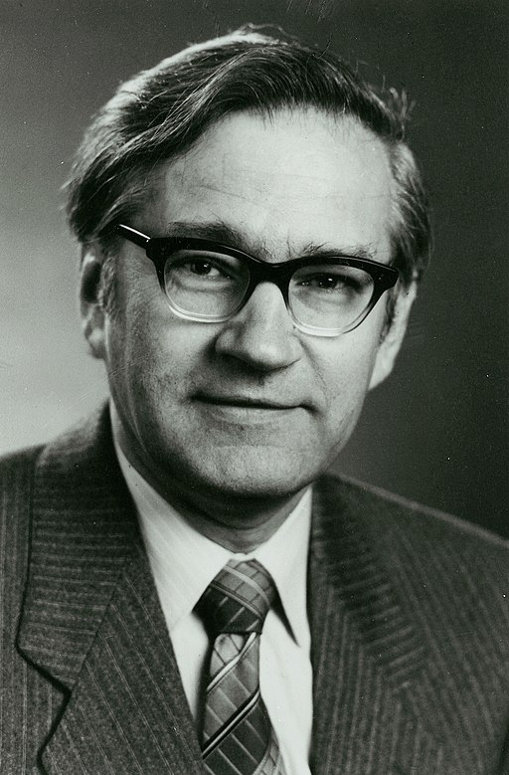ETH-Bibliothek Zürich, Bildarchiv / Fotograf: Unbekannt / Portr_13862 / [CC BY-SA 4.0](https://creativecommons.org/licenses/by-sa/4.0), via Wikimedia Commons (3)

**Richard Ernst** - a Swiss physical chemist who was awarded the Chemistry Nobel Prize in 1991 for his contributions towards the development of Fourier transform nuclear magnetic resonance spectroscopy (4). It took several decades for the scientific community to recognize the significance of this work, as detailed in the quote below from his [Nobel Prize Biographical](https://www.nobelprize.org/prizes/chemistry/1991/ernst/biographical/).

“The response to our invention was however meager. The paper that described our achievements was rejected twice by the Journal of Chemical Physics to be finally accepted and published in the Review of Scientific Instruments. Varian also resisted to build a spectrometer that incorporated the novel Fourier transform concept. It took many years before in the competitive company Bruker Analytische Messtechnik Tony Keller and his coworkers demonstrated in 1969 for the first time a commercial FT NMR spectrometer to the great amazement of Varian that had the patent rights on the invention.”  
- Richard Ernst

More photos and details about Ernst’s work can be found at cited source (4).

# Observation Experiments: Magnetic Moment Motion Impact on Local Magnetic Environment

One of the key differences between different states of matter is the relative motion of the atoms and molecules making up the sample. To develop a better idea of how the motion of atoms in the sample may ultimately impact our MR signal, let’s first observe how moving magnets with various amounts of motion can impact the magnetic field being measured at different locations in space.

To conduct these experiments, you will need:

1. a handful of small compasses to serve as local magnetic field sensors
2. a few small magnets who will act as our magnetic spins in the sample

The needle of each compass will align with the local magnetic field at the location of each compass. If the local magnetic field is *homogeneous* the compass needles located at different regions of space should all roughly be aligned, if the magnetic field is *inhomogeneous*, then the compass needles will be pointing in multiple directions.

## Experiment 1

*Procedure*

* Set up a small grid of compasses separated by 3 - 4 inches in a location where the local magnetic field appears to be largely homogeneous - most likely, the compasses are just aligning with the Earth’s magnetic field.
* Randomly place the small magnets in and around the grid of compasses and keep the magnets stationary.

*If you don’t have access to these materials, you can watch* *this video**.*

## Guided Inquiry Questions

1. What phase of matter would be the closest analogue of this experimental setup?
2. How does the magnetic field appear to vary over different regions of space (i.e. is it more or less homogeneous than before the magnets were added)?
3. Would you expect a sample that is analogous to this experimental setup to have a long or short relaxation time constant? Why?

## Experiment 2

*Procedure*

* Multiple students should move the magnets around. This motion should include rotating the magnets along with moving the magnets around the region of space where the grid of compasses has been set up.
* Other students observe the response of the compasses.

*If you don’t have access to these materials, you can watch* [*this video*](https://youtu.be/3XJVwv0q9lA)*.*

## Guided Inquiry Questions

**time-averaged** - average value over a period of time

1. What phase of matter would be the closest analogue of this experimental setup?
2. How does the **time-averaged** magnetic field appear to vary over different regions of space? Does it seem to depend on how fast the magnets are moving? How so?
3. Would you expect a sample that is analogous to this experimental setup to have a longer or shorter relaxation time constant compared with Experiment 1? Why?

# Testing Experiment: Molecular Motion Effect On

Based on the previous observation experiments, Alice and Sayed came up with the following hypothesis to explain how molecular motion may impact the relaxation time:

**Hypothesis:** The faster the molecular motion in the sample, the more homogeneous the spin magnetic environments, and the longer the relaxation time.

## Guided Inquiry Questions

1. Design an experiment that can be used to test the hypothesis given above. Include a pulse sequence diagram and explain your choice in the timing values you would use (e.g. , TR, etc.)
2. For your designed experiment, what would you predict to see in the resulting time-domain signal if the hypothesis above is correct? *Feel free to include rough sketches of your predictions!*

The data shown below are the || versus time for CPMG experiments performed with TE = 0.0008 seconds using mineral oil (blue) and neoprene rubber (red) samples. For easier comparison, the amplitude of the neoprene rubber data was scaled up by a factor of 5 to have a similar amplitude as the mineral oil sample. This scaling does not impact the time scale.

1. Perform your experiment - or look at the provided experimental data that Alice and Sayed collected - and use these results to make a reasonable judgment about the hypothesis.

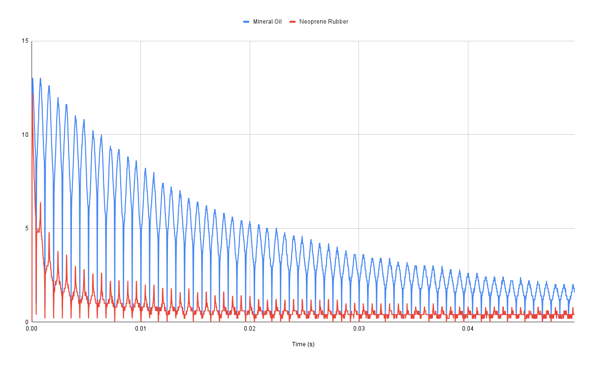

# How Does Molecular Motion Impact Relaxation Time Constants?

Below is a plot of what is generally found for and relaxation times for various **molecular tumbling rates**.

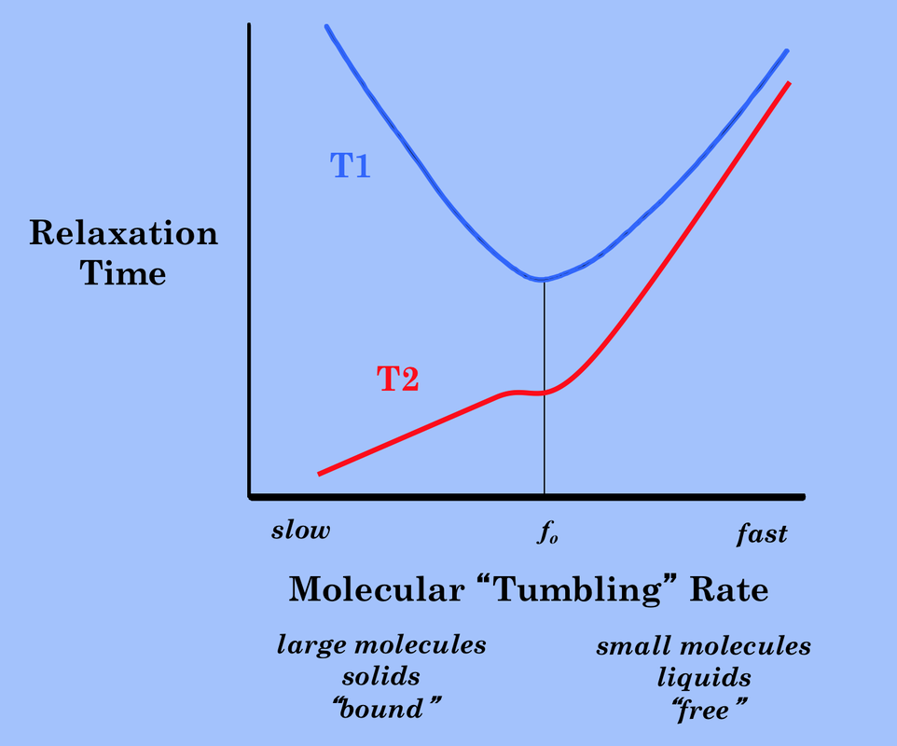**molecular tumbling rate** - how fast the molecules within the sample are moving around, with larger molecules and/or more solid samples having slower tumbling rates and smaller molecules and/or liquid samples having faster tumbling rates

Image courtesy of Allen D. Elster, MRIquestions.com (5)

## Guided Inquiry Questions

1. Does the plot for the relaxation time versus molecular “tumbling” rate match with your experimental conclusions?
2. Note that the correspondence of in response to molecular “tumbling” rate is not quite as straightforward. It is actually minimal when the tumbling rate is equal to the Larmor frequency. Provide a possible explanation given what we know about resonance (e.g., that using resonance gives the most efficient energy transfer between systems) and the fact that is related to the energy transfer between the environment and the quantum spins.
3. In the ideal MR experiments, we would have the longest possible time - so our signal lasts longer and we get sharper spectral peaks - and the smallest possible time - so we can repeat our experiments faster. Explain, using the diagram above, why solid-state NMR leads to non-ideal MR experiments.

# Reflection Questions

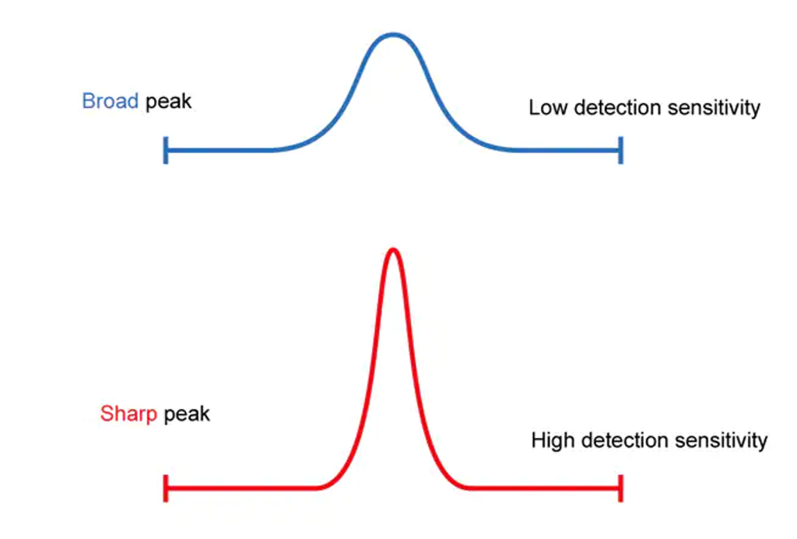Image courtesy of Shimadzu Corporation (6)

*RECALL:* How does an exponential decay in the time-domain signal impact the Fourier transform? As the signal decays faster (i.e. shorter relaxation time) what happens to the width of the peak in the frequency spectrum? (Hint: See Module 8)

1. In MR experiments, narrow peaks help both with detection sensitivity - signal strength - and spectral resolution - how easy it is to see distinct, individual peaks in the frequency spectrum. These both are very important for identifying peaks in the frequency spectrum and having higher resolution in imaging. One common way to get narrower peaks in solid-state NMR is to do [magic angle spinning](https://en.wikipedia.org/wiki/Magic_angle_spinning), where the sample is spun at frequencies up to 130 kHz about an axis that is tilted at the magic angle of 54.74 with respect to the magnetic field. (The magic angle comes from the mathematical formula for the spin-spin coupling causing the short , which is beyond the scope of this module.) Why might rotating the sample help narrow the spectral peaks, given what you have learned in this module?

*FUN FACT!* Hyperpolarized gas MR imaging uses hyperpolarized helium and xenon gases as non-toxic, non-radioactive inhaled contrast agents that provide functional and structural information about the lungs that cannot be obtained using any other clinical imaging methods. For more information, check out (7).

1. From the experiments above, we have seen that faster molecular motion leads to longer and longer and relaxation time constants. So you should presumably get much narrower spectra from doing NMR of gases. However, doing NMR on gases is even less common than on solids. Can you think of some other possible reasons why gases are not as commonly used for NMR experiments? *Hint: Another important factor is detecting the NMR signal, which is directly proportional to the number of spins we have in our sample volume.*

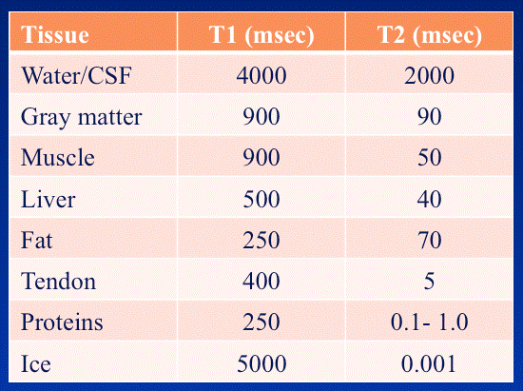

Image courtesy of Allen D. Elster, MRIquestions.com (5)

1. Looking at the table above, we see that water and cerebralspinal fluid have the longest time out of the tissues listed. Using what you learned about molecular tumbling rate and its impact on the relaxation time, explain why this makes sense.
2. In MR imaging (MRI), the brightness of the individual voxels (3D pixels) in the 3D image is related to the amount of MR signal one detects in that region of space, along with how quickly that signal decays as the signal is being acquired. Suppose we were doing an H MRI of a human head, which has a layer of fat outside the skull and cerebralspinal fluid and gray matter inside. Which of these tissues would show up as the brightest voxels in the image (i.e., have the most signal)? Which of these tissues would show up as the darkest voxels?

# Supplemental Readings

**Applications of solid state NMR:**

<https://analyticalsciencejournals.onlinelibrary.wiley.com/doi/full/10.1002/mrc.5071>

<https://www.ncbi.nlm.nih.gov/pmc/articles/PMC4413014/>

[https://pubs.acs.org/doi/10.1021/acs.analchem.2c02905#](https://pubs.acs.org/doi/10.1021/acs.analchem.2c02905)

**Overview of NMR spectroscopy for solids:**

<https://www.bruker.com/en/resources/library/application-notes-mr/nmr-spectroscopy-for-solids.html>

**Macromolecule effect on T1 and T2:**

<https://mriquestions.com/macromolecule-effects.html>

**Molecular motion effect on T1 and T2:**

<https://mriquestions.com/dipole-dipole-interactions.html>

<https://mriquestions.com/bo-effect-on-t1--t2.html>

## Cited Sources

1. <https://en.wikiversity.org/wiki/File:Phases_of_matter.svg> “Phase of Matter, Wikiversity”
2. [https://commons.wikimedia.org/wiki/File:CPG_Portraits_L3A0061_taken_by_Gabriella_Bocchetti.%C2%A9University_of_Cambridge.jpg](https://commons.wikimedia.org/wiki/File:CPG_Portraits_L3A0061_taken_by_Gabriella_Bocchetti.%C2%A9University_of_Cambridge.jpg%20) “Wikimedia Commons Clare Grey Portrait taken by Gabriella Bocchetti”
3. <https://commons.wikimedia.org/wiki/File:Richard_R._Ernst_1980s_(cropped).jpg> “Wikimedia Commons: Ernst Headshot”
4. [https://chab.ethz.ch/en/news-and-events/d-chab-news/2020/05/the-man-who-turned-molecules-into-spies.html](https://chab.ethz.ch/en/news-and-events/d-chab-news/2020/05/the-man-who-turned-molecules-into-spies.html%20) “The man who turned atomic nuclei into spies”
5. <https://mri-q.com/why-is-t1--t2.html> “Size of T1 versus T2”
6. <https://www.shimadzu.com/an/service-support/technical-support/analysis-basics/fundamentals/columns.html> “Gas Chromotography Columns”
7. <https://med.virginia.edu/radiology-research/research/hyperpolarized-gas-mr-imaging/> “Hyperpolarized Gas MR Imaging”